**Entry one (Week 3):**

Personal goals this semester:

1.How to understand, do and integrate the tasks of different roles correctly in an agile project.

2.Identify gradually an appropriate role in a management for myself by learning the lectures, workshops and doing assignments.

**Entry two (Week 4):**

**Summary:** This week’s topic is about the significance of the context and scope in an agile project. In addition, it introduced the how context and scope are captured and documented in an agile project by comparing the scope in different projects. In my opinion, it used the comparison approach of two examples (a product backlog vs a user story map) to discuss the relevant knowledge about the context and scope. The product backlog is also the primary method to document the scope in the agile project. Moreover, this chapter illustrates the reaction of a individual and a group to a behavior cause team problems during this week’s workshop.

**Analysis:** In this week’s lecture, it is mentioned that two important concepts. (Big picture and User stories) In my opinion, big picture is like a blueprint of visualizational communication system for the whole agile project, also as lecturer said in Piazza, it is related to the whole system, organizational value, strategy and planned outcome. It not only reflects the model of the comprehension for the system, but also constitutes the structure of the code and the named method of different functions which is convenient for the maintenance department. User stories in my idea is that the story of a user achieved a valuable aim by utilizing the system. There is an example to express the user story: As a <Role>, I want to <Activity>, so that <Business Value>. That is to say that we can replace the content between less symbol and greater symbol. For instance, as a <network administrator>, I want to <count the number of daily pageviews>, so that<calculating how many benefits I can obtain from ads >.

Figure 1, the answer to big picture in Piazza



**Connections:** Week 3 lecture’s topic is the introduction of leadership, management and project initiation. This week is the continuance of the last week and the foreshadow of the agile project to the next week. I have two courses with codes --- comp2410 and comp2300. Both of them need to do the assignment and review the lecture with a partner. Hence, we are in a group which means I should pay attention to the team cooperation and utilize what I learned in this week, even this course, to maximize the efficient and benefits. This chapter reminds me that I learned a course called comp2130 last semester which is similar with this course. We had 5 people in a group and drew the flow chart and table together. But actually, we didn’t have any backlogs and user stories. By studying this chapter, I recognize that keep the team members’ emotion and enthusiasm is first step to do the tasks in a project, especially an agile project. In addition, before comprehending the different tasks and roles, it is a better choice to understand what the workflow of agile project is. So I just used Google to search something related to the user stories and agile project. Finally, I found this website and summarized what I learn for that above in the Analysis part. (http://www.agilemodeling.com/artifacts/userStory.htm)

**Entry three (Week 5):**

**Summary:** This week’s topic is about the reason and the benefit we extract when we plan projects and the planning, schedule and lifecycle of the agile project. The plan must be with many values, such as clear and attainable. This is the most significant reason to make a plan and the foundation of creating a good plan. Based on what I learned, in my opinion, the lifecycle of the agile project is from the plan to the entire team can respond to the requirements quickly and create the value to the user. This process may iterates for several times until the team adapt to various requirements fleetly. There are typically 5 levels of agile planning with different goals to realize, respectively is project vision, product roadmap, release planning, iteration planning and daily planning. Furthermore, it demonstrates that using User Story Map (USM) to create the development plan.

**Analysis:** This week’s lecture is the extension of the last week. When considering the agile project plan, we should firstly refer to the big picture. The lecture I learned some features of agile project plan. These 5 factors for making good plan: Scope, time, cost, risk, resources. Moreover, the sequence of doing a right work by referring the 5 levels is also important. Meanwhile, I learned a lot from Google. Agile project plan is based on the features of the environment and organized repeatedly. In addition, the agile project plan is owned by the team and has 5 different levels as I described above. The second part is about creating user story maps. Based on the lecture and chapter book, I think create user story maps includes 8 steps.

1. Make 3-5 experienced people participate to the project
2. Have a brain storm in silence. That is, everyone writes down the user tasks.
3. Classify the similar tasks as a group on the table.
4. Rename these groups and use color pen to mark them.
5. Sequence the tasks in each groups in terms of the difficulty degree.
6. Depend on the ‘walking skeleton’, the leader begins to describe users’ stories and others ask some questions.
7. Finish the fundamental frame and all team members try to add some detailed user stories in each group.
8. Distribute the stories above and ensure the first release is small. Then go back to step 1 and repeat the step 1-7.

Figure 2

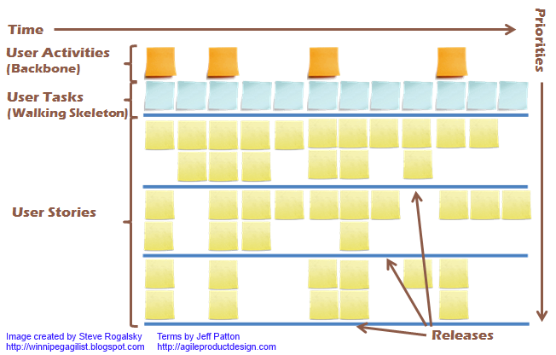

Figure 3 walking skeleton

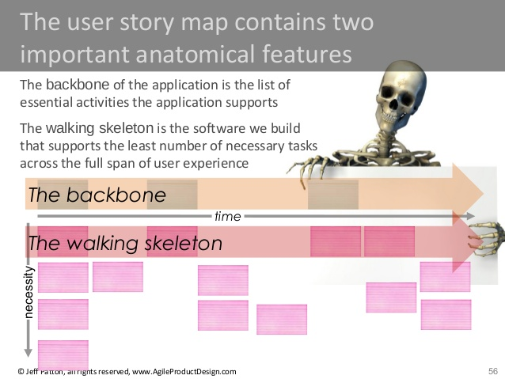

**Connections:** I am on the way of understanding agile project. Hence, I haven’t comprehended the roles and tasks properly. However, I have learned the agile project plan and big picture adequately. I think this will help me understand the roles and tasks in the future. In addition, no matter what roles I choose, this fundamental knowledge is necessary for every team member in the project.

**Entry four (Week 6):**

**Summary:** This weeks’ content is about agile project management and functional decomposition. Then it describes the two significant concepts in this chapter – ‘ready’ and ‘done’ and what benefits they provide. Next is the extension of the definition of done (DoD) which means a set of rules which is accepted by the team as a guide to ensure that user stories are done and wait for approval of the project manager. Following is the second part (decomposition of user stories). Firstly, we should find the right size for development. And when necessary, initiating long-term plan, need an initial estimation rather than a perfect plan and before developing them, we should use Epics instead of smaller stories and split them depend on independent, negotiable, valuable, estimable, small and testable.

**Analysis:** The ‘ready’ and ‘done’ are the new concepts which is also the important point

of this chapter. In my opinion, ‘ready’ is a set of rules that the team adopts as a guide for a story to be moved reasonably from the backlog to an agile project and ‘done’ is accepted by the team as a guide to ensure that user stories are done and wait for approval of the project manager. In addition, nothing is really ‘done’ and things are always ‘ready’ to the next step. Here is an example which I found on this website. (<https://www.quora.com/What-is-the-difference-between-the-Definition-of-Done-DoD-and-the-Definition-of-Ready-DoR-in-Agile-processes)>

Consider this: you're at the office. Random people come up to you, and each of them dumps work onto your desk. Before you know it, you've got a backlog that's 3 feet high and rising. 

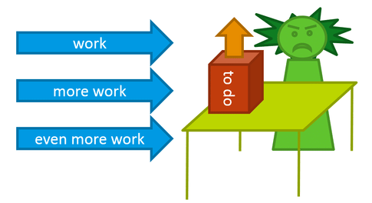

What can you do? Limit the work coming in by setting up a Definition of Ready: from now on, you will accept only items that comply with certain criteria – the most obvious being: “Is this in my job description?” Yes, that's right, your DoR will consist of acceptancecriteria.

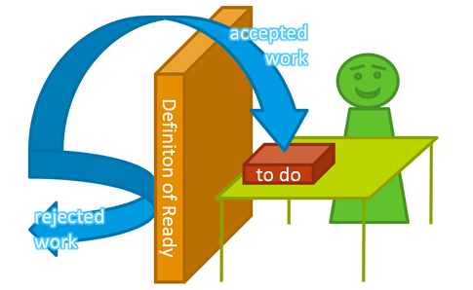

Phew, that's better! Now you can actually get some work done. But how do you determine when you're actually “done”? Easy, you set up another set of criteria: a Definition of Done. Now you are ready to tackle the work one item at a time. You quickly get into the zone where work flows fast and smoothly. And what do you do when you're done with an item? Pull the next work item, for as the [”Cult of Done” Manifesto](http://www.brepettis.com/blog/2009/3/3/the-cult-of-done-manifesto.html) so cleverly puts it:

*The point of being done is not to finish, but to get other things done.*  
At the end of the day, you've done a whole load of work and you drive home satisfied.



In the decomposition part, the first and the most significant thing is to recognize the right size for the development. Then discriminate the opportunity to use the Epics and decompose Epics follow the INVEST model.

**Connections:** I have learned the plan for agile project management and decomposition of Epics. This is a second but solid step for me to complete my goals. Also, this chapter is a foundation of learning agile project. The next chapter is called determining the minimum viable product which is an extension of the planning in agile project management. Maybe I can understand the lecture well with the knowledge of this chapter.

**Entry five (Week 7):**

**Summary:** The minimum viable product (MVP) is the key point of this chapter. Firstly, it describes the end-to-end experience which stands for the process that customers do anything when they use products, device, services etc. from beginning to the end. And in order to understand easily for us, the e-book illustrates two example – total purchase from the App store and drink milkshake on the work way. Then introducing the definition of the minimum viable product before understanding the component of the MVP. Last content is about the connection between user story maps and the MVP.

**Analysis:** The comprehension and divergent thinking of End-to-end will be discussed

below. After reading and understanding the MVP and component of it, I think I should find some materials and articles for better digesting the knowledge. Then I found an article describing many methods to checking the MVP. In my opinion, these are at least 13 kinds of effective ways checking the MVP.

1. Communication with users
2. The page of login
3. A/B test, that is to design two different format for users and receive feedback.
4. Launch ads
5. Raise fund
6. The introduction video for products
7. Based on the existing resource.
8. SaaS & PaaS, which means not to throw into too much at the beginning.
9. Blog
10. Virtual MVP
11. Guest MVP
12. Digital & paper model
13. Page for pre-order

**Connections:** End-to-end model reminds me of the course COMP2410 computer network. In the transport layer, end-to-end is realized by infinite points. This model also applies to many software development areas with different definition and benefits. In IT companies, end-to-end is a connection between users and market or other stakeholders which ignoring the intermediate link and economizing the cost of labor and management. Hence, on the way of the understanding roles and tasks, I adequately understand end-to-end and the MVP. Then moving to the next step – Estimation.

**Entry six (Week 8):**

**Summary:** This week’s topic is the survival concepts – estimation. It is well known that considering the ultimate goals, time cost and budget which is used to determine whether the project is worth doing before designing the blueprint for the project. However, it is difficult to estimate accurately without any problems. Hence, writing a graph including estimate variability, time and the completion of different phases is a necessary method to achieve the final estimation. In addition, these important concepts and techniques should be considered during instituting the estimation: 1. Elapsed time 2. Velocity 3. Relative units of measure (hours, points etc.) 4. Ideal time 5. Story points. Then the second important part is planning poker which is an estimating and planning technique with the numerical face and poker appearance. In this week’s workshop, we just use it to mark the sequence of finishing different stories based on the time cost. Lastly, it describes the methods for measuring the velocity and determine the proper iteration length.

**Analysis:** In practical team works including our expression in the workshop, we always

ask the team leader ‘How long does the project take?’. After I learn this chapter, I recognize that it is a kind of estimation. In the workshop, we play the planning poker and decide length of the time cost of pilot. After I search on google, I learn that estimation has these three features:

1. Team work estimation, that is all team members participate in and use some methods like planning poker.
2. Focus on the time cost and difficulty degree, use relative calculation instead of absolute calculation.
3. Record the speed of each scrum team in Sprint.

**Connections:** The estimation in agile projects is significant which determines the direction of project and the value of the works. It is the very first step for most agile projects. Based on my experience in the workshop, I have learned well the first step for estimation. Step 2 and 3 is the direction of the progress for me. When I master the estimation methods in the future, maybe I can institute a better project plan and measure whether the project is worth doing. I am on the way of learning more detail of the agile project.

**Entry seven (Week 9):**

**Summary:** This week, the second survival concepts – Project execution and Control needs us to learn. Traditional or agile project approaches for us are sufficient to develop a project without delay even failure. However, we may use these 5 levels in agile project: vision, roadmap, release, iteration and daily plan. Then in the release plan part, the chapter describes 5 steps in planning a release.

Figure 1 5 steps



Next, the second important section is about iteration planning which is also called Sprint. It distributed story points into tasks and time cost in hours with two methods (velocity-driven and commitment-driven). In order to monitor and control the schedule, we need to finish the next step – project execution. Potential risks, activities need to be conducted and indicators of poor project management are obviously analyzed by project monitoring and control. Then over the wall software development is such a negative example which separates the working phases and responsibilities then cause the fail communication and over-estimated. Lastly, project tracking is useful to find which phase has a mistake by burnup chart, generic task board, actual task board and burndown charts.

**Analysis:** Iteration planning makes the project maintain vitality and viability and a

successful and entirely planning project is always dynamic and adjust itself from time to time. In contrast to the release planning, it costs less time and based on the task rather than user story. In this week’s workshop, we have discussed that when consider the time cost of a project, we should think about the capability of every team member and estimate an appropriate duration of the project. Meanwhile, considering the learning skill of team members and many conflictive issues, while doing project execution, the structure, the cost, the time of phase and the improvement are all dynamic. Therefore, after execution, timely monitoring and controlling is necessary and may keep the project away from the troubled direction.

**Connections:** This week I learned about the knowledge of execution and iteration planning. They are the deep-level concepts in agile project. To sum up, execution help the team keep the track while iteration planning repeats to plan the project in order to achieve a balanced and reasonable cost and time work. Moreover, the summary between the release planning and iteration planning written by myself help me learn these significant approaches in agile project. These knowledges point out a correct direction for me to keep the way to understand the agile project fully.

**Entry eight (Week 10):**

**Summary:** This week’ topic is an extension of the dealing with reality – governance and communicating including how to make presentation better and conducting a successful meeting. Firstly, it demonstrates some terrible expressions of presentation and some solutions to improve them. Then it illustrates some suggestions for us to make a better presentation. Combining e-book and my opinion, I think clear structure and reasonable distribution of slides are the first consideration. For students themselves, body language and eye contact are also significant instead of read the article like a robot. Next part is the meeting. Each team members should attend to the effective iteration review meeting with the feedback provided by the iteration retrospectives because all the stakeholders should obtain a balance and an unambiguous aim. There are also two other meeting in agile project – AND/OR iteration planning meeting for the beginning of the iteration and daily ‘stand-up’ meeting for daily work summary and adjustment. Lastly is about project governance. It contributes to diminish the difficulty and make the decision on time once there are some changes in project.

**Analysis:** This week’s topic is just a review and extension. For governance and meeting

part, I think that what I summarize is what I learn. The most important is the presentation. In my opinion, firstly, the slide must be well planned and structured with clear ideas on them. Then in order to show the fluency, everyone in the team should memorize what he will speak in the stage and try to adjust the speed for the understanding of audiences. When he or she is on the stage, as I describe above, body language and eye contact is the most important behavior. Although everyone will definitely feel nervous, smiling is a perfect tool to release the stress of speaker and audiences. Fortunately, our group in the last week’s presentation is not too bad due to accomplishment of key points above.

**Connections:** The presentation is always one of my weaknesses. Although increasing the self-confidence and presentation skills is not my goals in this semester of learning agile project, as a team member of the group, I should not hinder the group in presentation and I must try my best to help the group and each member gain higher marks. This cohesion cannot learn from any courses. I am glad to have this wonderful group and get the cooperation each other. The cohesion of the group when we do brief paper together and practice the presentation shows obviously. It is a precious wealth for me to participate the group work in the future even though it is not my aim.

**Entry nine (Week 11):**

**Summary:** This week talks about software quality and risk management. It is well known that quality is concerned by various areas, especially for the software. Based on this situation, we need quality management by two approaches which is pro-active and re-active to operate all actions and ensure the quality in the same time. Then these is an example which is described in the lecture: London Ambulance Service (LAS). The LAS system in 1992 misoperated to store the important data of the status of the London ambulance and continuously failed to stop the system error which lead to a terrible consequence that many patients cannot be treated and cured on time even 46 people died in this disaster. It happens that there is a similar case in ICS and NASA program. After the quality is about the risk management. It is different from people’s knowledge that why risks have evaluation and benefit. Risk management prepares the project manager to take advantages of appropriate risks, decrease the surprises, improve chance of reaching project performance and offer better control and a pro-active approach, which are guarantee the quality in agile project. Last is the extension of risk management in agile project with some tools like product mission, product roadmap etc.

**Analysis:** Apart from the definition, the example, the technique and the approaches, we

should pay attention to what is the standard of the quality. We used to refer the user satisfaction as the degree of quality. As the e-book says, when we begin to design a project, we firstly consider the stakeholders’ expectation and received their feedback as a reference. This traditional method is no doubt reasonable. However, if a common function needs lots of time and cost and stakeholders want to use it, is the function worth designing and realizing? In my opinion, stakeholders’ thoughts and feedback can be a part of references, but the team must have their initial goals and original intension. In addition, prejudgement which means avoid the problems instead of finding and solving them is also a kind of assessment of quality. Therefore, the standard of quality is the combination of prejudgement, stakeholder’s thoughts and time and cost. To measure the quality of a software, we should focus on these 4 aspects.

**Connections:** Quality is the most attention for almost everyone. Except the quality, I should focus on the second part of this chapter. In order to understand what the team cooperate each other, I search the google and find the solutions for each role during the risk happened in agile project:

CEO:

1.Ensure the team is clear with the approach

2.Update ability change on time

3.Support the team to build up the competence

Project manager:

1.Improve risk monitoring and control

2.Remove the impediments

Team members:

1.Improve risk awareness

2.Adjust the solution to the requirement

I think these may help me comprehend the risk and different roles and tasks in agile project for writing a better summary in the last entry.

**Entry ten (Week 12):**

Review the entries above, I have adequately understood the agile project. The big picture, the lifecycle, the benefits, the user story, the concept of ‘ready’ and ‘done’, the end-to-end model, the MVP, the estimation, the execution and iteration, the governance and communication and quality and risk management. In the workshop, we did the planning poker and pilot project. Moreover, we read the Husky Air CEO’s story and made the brief paper and presentation to point out and focus on those terrible issues due to the lack of the agile project experience. In this semester, I really learn a lot about the agile project and they are all my precious fortune on the way of understanding the agile project. In the next group work or when I do a job in the future, I may present some suggestions to the project manager or some team members without any agile project experience because I have primarily comprehended the tasks and roles of agile. Regarding to my ideal role in the project, I should consider to be an experienced worker, a role between the project manager and common worker. I do understand the agile project and try to institute a agile project in the future group work. However, I have insufficient confidence and ability of leader. That is why I cannot be a project manager. May be in the future study life, I will learn some courses and lectures about the team leader and that is my direction of improvement. Based on the situation now, I suppose to give myself an experienced worker role.